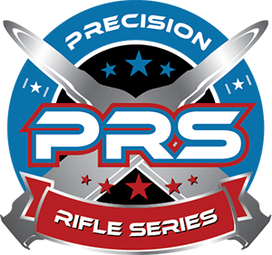

Long Range Shooters of Alaska
Second Annual 2-Day PRS Clinic!
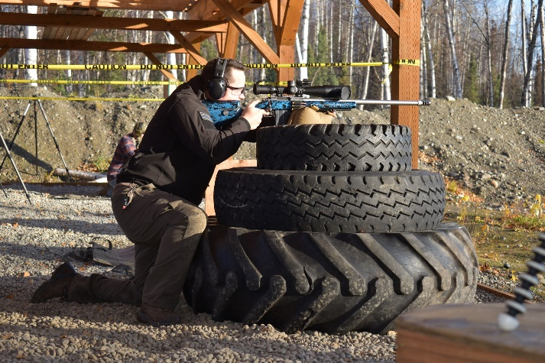
Designed for the new competitor…. (Like this guy)
Students will learn:
- Rules / Safety / PRS Basics
- What to expect on Match Day
- Gear / Equipment Overview
- Positional / Prop / Movement Drills
- On the Clock / Time Management
- Match Simulation / Multiple Targets
Required Equipment:
- Rifle chambered in 30cal or smaller (3200fps max)
- Scope min 10x or greater (exposed turrets)
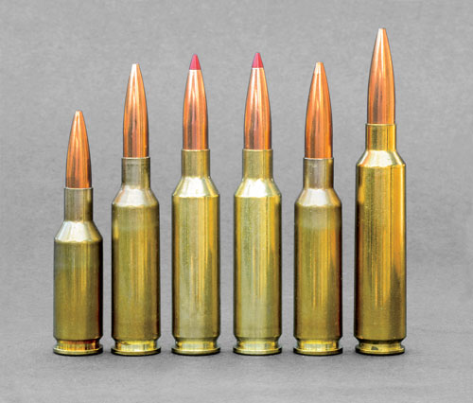
- Bipod / Rear Bag / Magazines (if applicable)
- Ballistic App or Calculator / Pen / Notepad
- Solid Zero / Muzzle Velocity (will confirm Day 1)
- Food / Water / Snacks
- AMMO Round Count – 200
Students will have access to a multitude of
High quality gear and accessories to try out.

May 7th and 8th 8am-4pm / Upper Susitna Range
Slots Available: 15
COST: $200.00* (Paid in advance)
Contact - aklongrangeshooters@gmail.com for signup / questions

*All Proceeds go to LRSA Club for Match Improvements
**This is NOT a Long Range Course for Fundamentals of Marksmanship

